**THE WEATHER INFORMATION DISSEMINATION SYSTEM HANDOVER AND SUSTAINABILITY PLANS**

Table of Contents

List of Figures 3

List of Tables 4

1. Introduction 1

1.1 Background 1

1.2. Justification for developing WIDS 1

2. System Structure and Requirements 3

2.1. WIDS in depth 3

2.2. WIDS Performance indicators 16

2.2.1. Number of Requests and Subscribers 16

2.2.2. Number of successful Requests 21

2.2.3. Feedback from users 21

2.2.5. Downtime 22

2.3. Requirements for maintaining operation of WIDS 22

2.4. Challenges encountered in operationalizing WIDS 24

2.4.1. Cost of ICT Infrastructure and Services 24

2.4.2. Challenges in Raising Awareness 25

2.4.3. Skill level of developers 26

2.4.4. Interruptions in Technology 26

2.4.5. Accuracy and timeliness of forecasts 27

2.4.6. The cost of missing a forecast 28

2.4.7. Limited Number of Weather and Climate Products 29

2.4.8. Translating forecasts 29

2.4.9. Information entry 30

3. Sustainability Plans 38

3.1. Source code 38

3.2 Support documentation 38

3.3. Incorporating New Requirements 39

3.4. Operation Costs 40

3.5. System Hosting 41

3.6. Translations 41

3.7. Awareness 41

3.8. Collaboration 41

4. Proposed Handover Plan 43

5. Recommendations 44

**List of Figures**

Figure 1: Architecture of WIDS 4

Figure 2: WIDS Daily Forecast disseminated via the web portal 6

Figure 3: Daily forecast disseminated via the USSD mobile application 7

Figure 4: Translated seasonal forecast disseminated by WIDS 9

Figure 5:Sample Marine forecast disseminated by WIDS 10

Figure 6:Sectoral advisory messages 11

Figure 7:Stakeholders of WIDS 12

Figure 8:Daily USSD usage trend during radio talk shows and regional launches 16

Figure 9:Usage tend for two months after radio talk shows and regional launches 17

Figure 10: Web visits 18

Figure 11:Sector requests 19

Figure 12: 2021 daily USSD-Usage trend 20

Figure 13: Overall system statistics 20

Figure 14: Successful requests Vs other requests 21

Figure 15: Sample forecast form for the Marine forecast 31

**List of Tables**

Table 1: WIDS ICT Enablers 14

Table 2: Requirements for maintaining operation of WIDS 22

Table 3:Operational Costs of WIDS 24

Table 4: Platform/ methods used to raise WIDS awareness 25

Table 5: Service Provider Technology failure 27

Table 6:Summarized table of all marketing strategies 34

Table 7: Support documents 39

Table 8: Operational Costs of WIDS 40

Table 9: handover process 43

# Introduction

## Background

Weather and climate information has gained global attention due to the different sectors the information impacts, namely agriculture, health, water and sanitation, transport and tourism among others. Efforts have been undertaken to develop the science of weather prediction at the expense of dissemination.

To be effective, it is necessary that the weather and climate information be shared with users not only in a timely manner but also in a format that can be properly understood and any action required taken. This is why the developed weather information should be user-centered.

A couple of efforts to disseminate weather information have been proposed. Traditionally, weather and climate information has been given through radios, televisions and print media. The challenge with this is access considering the limited space in media amidst competing interests. To address this, emerging studies are attempting to use mobile phones and web interfaces which are proving useful.

## 1.2. Justification for developing WIDS

There is an increase in the weather events that are happening and they are becoming more adverse. Extreme weather conditions like floods, extreme heat, drought and others are problems that can lead to loss of lives, property damage and financial losses in all sectors. It is therefore important that we get accurate and timely weather information for adequate preparation against these conditions. UNMA, as the national authority, is already generating this information in the form of forecasts. The challenge however, is that not everyone is accessing the information. Different platforms such as radios, televisions and the web are being used in the dissemination exercise, but a vast majority of the population still suffer the diverse effects of harsh weather elements.

WIMEA-ICT project has embraced ICT because it is now more affordable and easily accessible. ICT as a mode of dissemination ensures timely dissemination, wide coverage, and most importantly, custom requests. Weather information previously disseminated via television for instance, has proven to be limited to certain areas and not covering others. With ICT, the forecasts will not only be customised but also timely and conveniently accessed.

# System Structure and Requirements

## 2.1. WIDS in depth

A major finding from the research carried out among stakeholders is that although residents in rural areas cannot access a computer or internet connection, they can afford a simple feature mobile phone. This was a perfect opportunity for the WIMEA-ICT team to get to work in 2016, and in collaboration with UNMA and other stakeholders, developed the Weather Information Dissemination System (WIDS). The Weather Information Dissemination System (WIDS) is an effort of several partners including WIMEA-ICT project, Uganda National Meteorological Authority, Makerere University, World Vision Uganda and NORAD, among others. It was designed to enable stakeholders access weather forecasts and advisories through simple phone SMS application by dialling *255*85# and through the web system www.wids.mak.ac.ug/wids. The Weather Information Dissemination System has been developed over a period of 4 years (since 2016) and has been customized at the Ugandan level into 9 local languages, with access to translated forecasts being granted by World Vision Uganda. UNMA already has the mandate to provide the information that the system needs, and the role of WIMEA-ICT project was to create for them a platform where it would be disseminated.

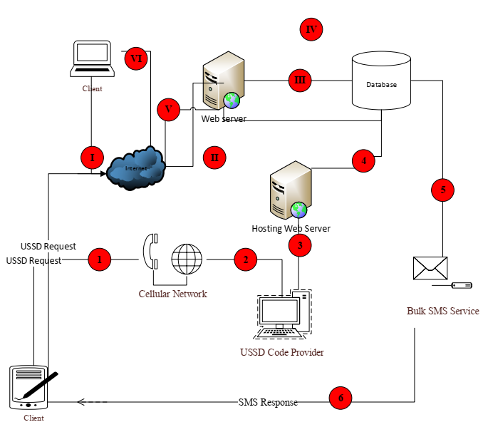

*Figure 1: Architecture of WIDS*

The dissemination process is done via 2 platforms, namely: USSD Mobile application and a web portal.

**USSD Mobile application** – a code was acquired (*255*85#), which is accessible on any mobile phone at a fee of 160-300 Ugandan shillings. The project is paying several of the service providers to reduce the cost burden on the users. Also on a good note, the stakeholders that have been engaged are willing to pay, since the SMS charge is minimal compared to the huge losses that some of them have incurred in the past as a result of weather-related catastrophes. Also this cost is further considered minimal given that the charge can be shared by farmers in their group settings i.e. a given farmer group can share the cost across its members.

**A web portal** is available for the stakeholders that may be weary of the mobile phone charge, have access to computers and internet connection, and desire more detailed information. The advantage with the web portal is that it is used for entering the information that comes in from UNMA, after which it is picked by the USSD application. In addition, data management is made easy, like broadcasting appreciation messages to users and issuing out warnings once the system indicates an imminent disaster. Features like alerts and feedback enable the team to constantly improve the system to fit the users’ needs.

Products provided by the system are: daily forecast, seasonal forecast, Marine forecast, Monthly forecast and advisories.

**Daily Forecast**

WIDS disseminates 6-hourly daily weather information for 135 districts within the 18 regions of Uganda. This information is structured and presented to the user in a form that is simple, precise and understandable.

The daily weather information disseminated includes:

* weather outlook,
* wind strength,
* mean temperature,
* wind direction and
* Weather summary

This information is disseminated in four sets or periods of the day. These are Early Morning ( 12:00 Am-6:00 Am ), Late Morning ( 6:00 Am-12:00 Pm ), Late Afternoon ( 12:00 Pm-6:00 Pm ) and Evening ( 6:00 Pm-12:00 Am )

Users who subscribed to Daily forecasts always receive daily forecast information for the next day at exactly 12:01 PM. This is done using a push method; users do not need to daily *255*85# to access weather information, the system automatically sends the information to the user based on the district registered during the subscription process. For Example, if you subscribe to daily forecasts for Uganda, the system will always send Kampala’s daily weather every day. Figure 2 shows Daily forecast information disseminated by WIDS via web.

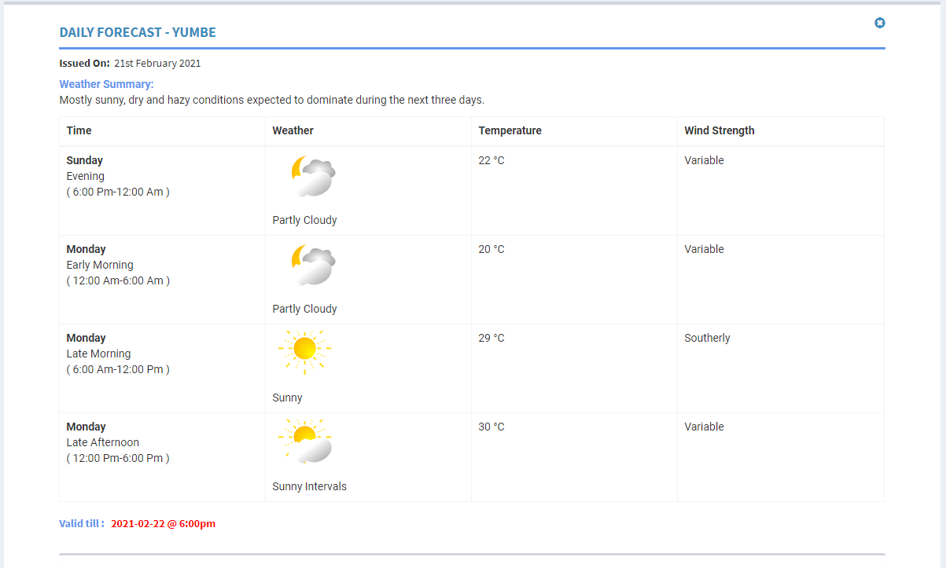

*Figure 2: WIDS Daily Forecast disseminated via the web portal*

Figure 3 shows Daily forecast message disseminated by WIDS USSD application.

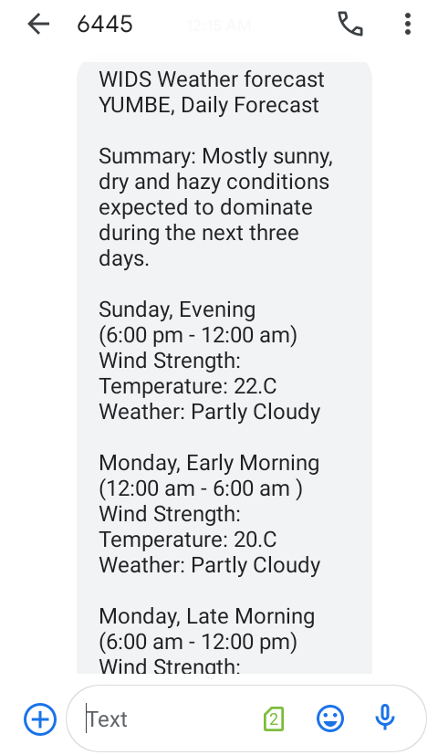

*Figure 3: Daily forecast disseminated via the USSD mobile application*

**Seasonal Forecast (3-4 months)**

Three seasonal weather forecasts are issued in a year; March to May (MAM), June to August (JJA) and September to December (SOND). These forecasts give advisories on likely weather/climate conditions and impact on various sectors such as agriculture, works, transport and infrastructure, and disaster management.

A typical seasonal forecast issued to the public by UNMA is incomprehensible and too technical for the rural farmers.

To address this, WIMEA team had to restructure the format of the data to be disseminated and also translate the forecast into local languages. This has improved understanding of the seasonal scientific weather/climate forecasts and reduced misinterpretation. The seasonal forecasts are currently available in 9 out of 54 languages spoken in Uganda.

Smallholder farmers mainly access these translated forecasts via the USSD mobile application. Additionally, users with smartphones can also access the translated forecasts from the WIDS website and relay to the public. Typical translated seasonal forecast disseminated by WIDS web application is shown in Figure 4.

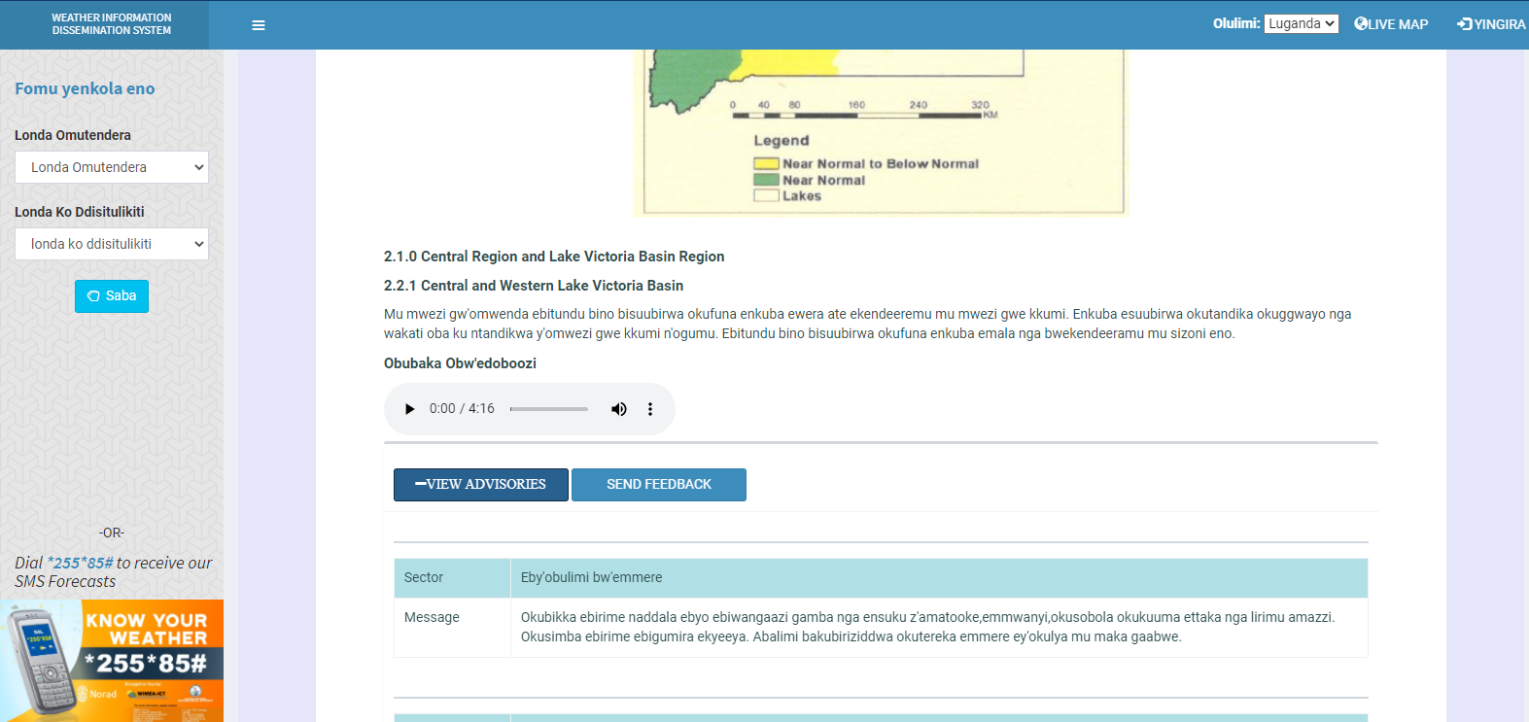

*Figure 4: Translated seasonal forecast disseminated by WIDS*

**Marine forecasts**

This a 24-hour Marine forecast (provided by UNMA) on Lake Victoria for fishing boats, small crafts and communities in and around the lake. It is issued twice a day to provide early warning to save lives and property.

Fishermen on Lake Victoria and islands in Lake Victoria are provided with forecast information that cover a period of 24 hours but the forecast is six hourly.

The 24 hours forecast released twice a day gives people guidance about when it's safe to travel on the lake and when to stay on the shores. When there is severe weather, people planning to use the lake will have information to take proactive actions whether to wear a life jacket, carry enough fuel with them when they decide to sail on the water.

The Marine forecast disseminated by WIDS covers all the landing sites in the four zones that is, Entebbe and Northwest, Buvuma and Northeast, Kyotera and Southwest and Migingo and Southeast. A sample of marine forecast disseminated by WIDS is shown in Figure x.x.

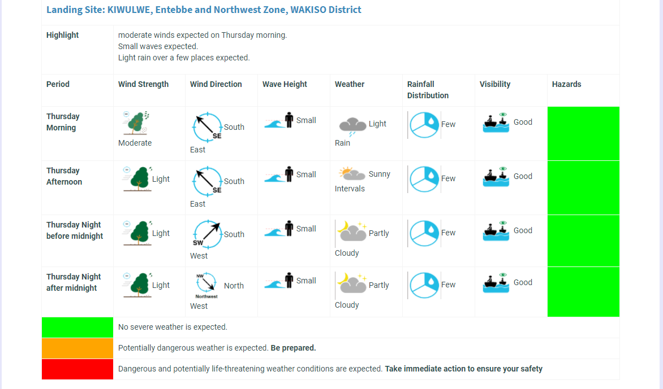

*Figure 5:Sample Marine forecast disseminated by WIDS*

**Advisories**

As earlier said, Seasonal forecasts disseminated by WIDS alsogive advisories on likely weather/climate conditions and impact on various sectors such as crop, harvesting, planting, animal husbandry, pests and diseases, apiary, water, works, transport and infrastructure, and disaster management. These are also disseminated in local languages (both in text format and audio). Figure 6 shows a sample of advisories disseminated by the WIDS system.

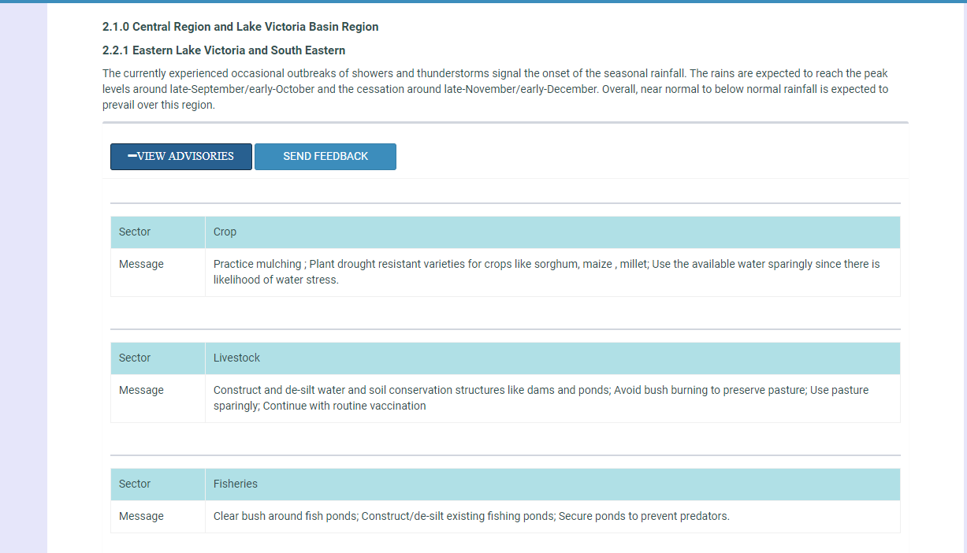

*Figure 6:Sectorial advisory messages*

There are two main features in the system:

v)USSD response in either sms or audio format

vi)Languages (9 languages so far)

**WIDS Stakeholders**

Various stakeholders played different roles and responsibilities towards the success of the WIDS project. The stakeholders and influencers are in five (5) categories, namely;

* Information generators
* Funders
* ICT Enablers
* Innovators and
* Users

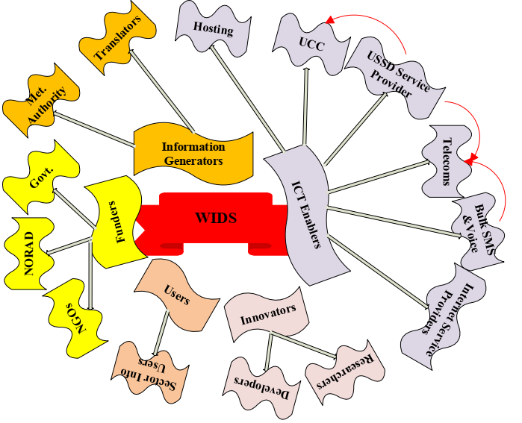

*Figure 7:Stakeholders of WIDS*

**Innovators**

These include product developers and researchers. Developers performed project design and development activities according to user specifications. They also worked with the project manager in developing the project plan, budget and schedule. Researchers include principal investigator who designed the research, research staff or students who collected, created, processed and analyzed data, external contractors with a role in data collection, collation or processing, support staff for managing and administering research, institutional IT services providing data storage, security and back-up services and external data centres or archives who facilitated data sharing.

**Users**

Some of the requirements that were used in the development of the system were gathered from users with the aim of improving the system usability, performance, and usability.

A given set of users was selected to continuously test the performance and usability of the system throughout its development process.

**Funders**

These played a big role in supporting the project financially. Funders include NGOs, NORAD and government.

These have always been providing financial support from the very beginning of the WIDS project and seen it through till the end. These funds have helped the WIDS project in a number of activities and this has made the system operational despite the high costs involved in maintaining its operations. These costs included purchase of bulk messages, securing the USSD extension (*255*85#), airtime during training, promoting system awareness via radio talk shows and regional launches, among others.

**Information generators**

The content and forecast information disseminated by WIDS is generated by the Meteorological agency (Uganda National Meteorological Authority, UNMA) and mostly translated by World Vision.

Uganda National Meteorological Authority provides forecast information that is disseminated by the WIDS system and World Vision handles the translation of the Seasonal forecast into different local languages.

**ICT Enablers**

These include hosting, UCC, USSD service provider, telecoms, bulk SMS and voice and internet service providers.

*Table 1: WIDS ICT Enablers*

|  |  |
| --- | --- |
| **ICT enabler** | **Role** |
| Uganda Communications Commission (UCC) | Regulate the Communications sector, which includes Telecommunications, Broadcasting, radio communication, postal communications, data communication and infrastructure. |
| USSD service provider | Provides a USSD Gateway that allows mobile subscribers to send USSD messages and to receive information and services from mobile operators, as well as third-party Value-Added Services (VAS). USSD messages are session-based, which means real-time connection is established for two-way data exchange.  Regulated and controlled by UCC. |
| Telecoms | Provide the technology necessary for communication through the internet, phone or wirelessly. Telecoms also provide an infrastructure necessary for passing voice, words, and audio weather information to various stakeholders.  Telecoms are regulated by UCC. |
| Bulk SMS provider | Provides bulk messaging service which the system depends on to send forecast messages to USSD users.  The bulk SMS provider is controlled and regulated by the telecoms |
| Voice Service provider | Provides voice service which the system uses to disseminate voice forecast messages to USSD users.  These voice providers are controlled by the telecoms. |
| Internet Service provider | Provides a myriad of services for accessing, using, or participating in the Internet. Internet services typically provided by ISPs include Internet access, Internet transit, domain name registration, web hosting, Usenet service, and colocation. |

## 2.2. WIDS Performance indicators

In order to increase the use of the system, it was important to come up with performance metrics such that problems could be identified in order to improve and deliver a system, which satisfied user requirements. The Performance indicators include:

### 2.2.1. Number of Requests and Subscribers

Requests can be made on both the website using the browser and an active internet connection and also via the USSD using a mobile phone for the weather forecast.

The number of requests and subscriptions greatly indicates the coverage, popularity, accessibility, reachability and usefulness of the system to various stakeholders.

High numbers of requests were realized in periods when WIMEA held regional launches & talk shows from 11th to 18th September 2020. The major goal of these talk shows and regional launches was to popularize, disseminate and spread information about the WIDS system and how forecasts can be easily accessed via the web and USSD **\*255*85**# code to all Ugandans.

**Daily USSD usage trend from 11th - 18th September 2020**

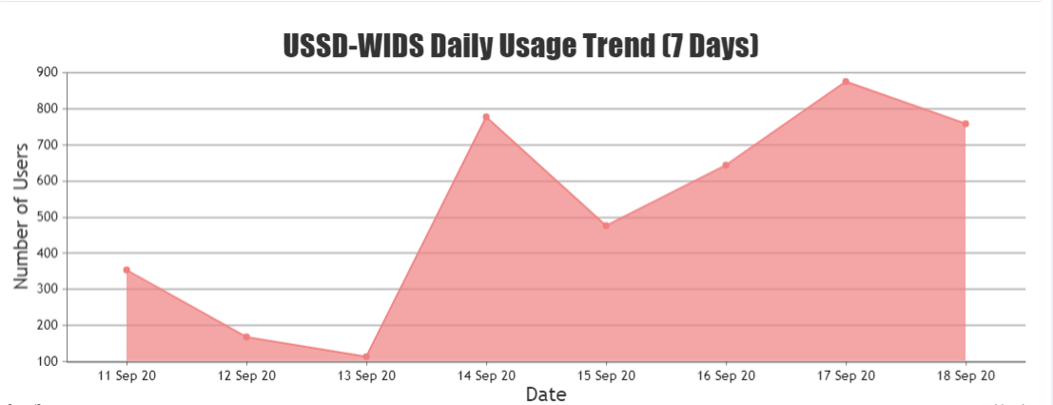

*Figure 8:Daily USSD usage trend during radio talk shows and regional launches*

**61 days after radio talk shows and regional launches**

This shows what happened after radio talk shows and regional launches.

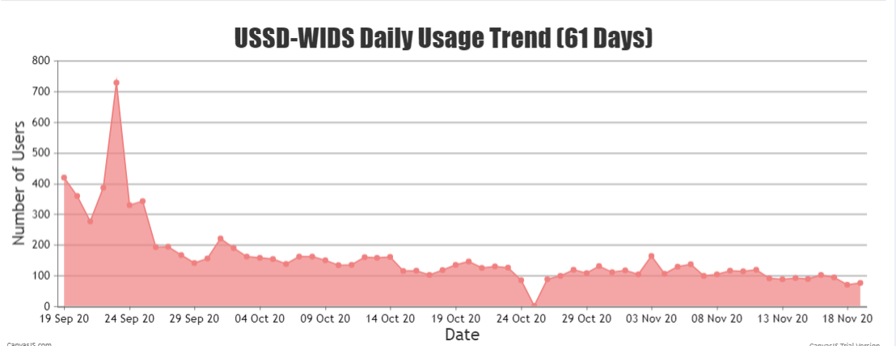

*Figure 9:Usage tend for two months after radio talk shows and regional launches*

Requests via the website were also recorded though they were less compared to this archived via the USSD. This was an indication that the USSD requests are more often made on a daily basis.

**Consider the web visits shown in the figure below**

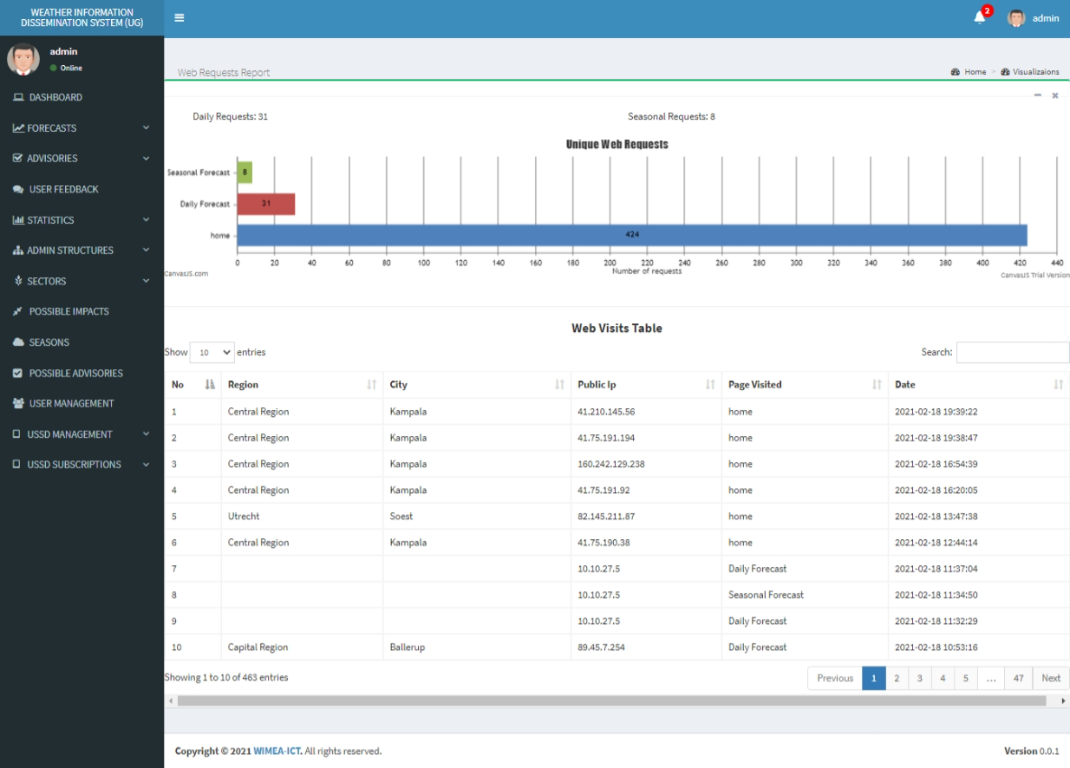

*Figure 10: Web visits*

**USSD Sector-request Analysis**

This indicates the most requested sectors.

Sector requests can only be made via the USSD using a mobile phone.

The requests are mainly made to a number of sectors namely; planting, fisheries, water, livestock, health, crop, infrastructure, works and transportation.

It’s observed that a larger number of requests were made for the crop sector followed by water

**Consider the statistic graph shown below**

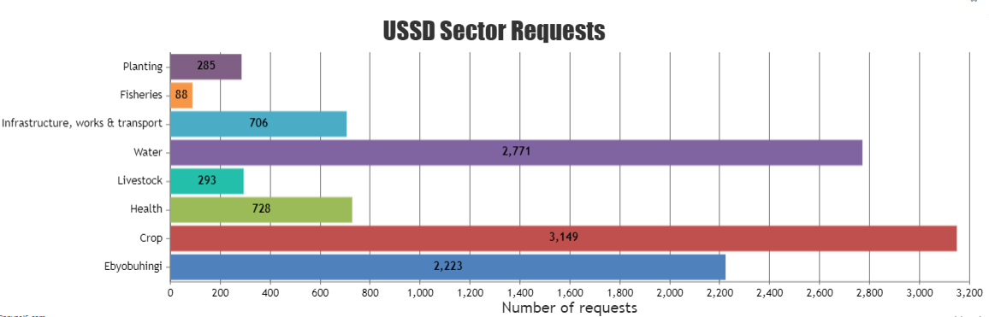

*Figure 11:Sector requests*

**2021 Daily USSD usage trend**

The graph below shows the daily requests received since 1st January 2021.

Between the dates of 13th and 18th January 2021, there were no requests made due to the shutdown of internet access in the country.

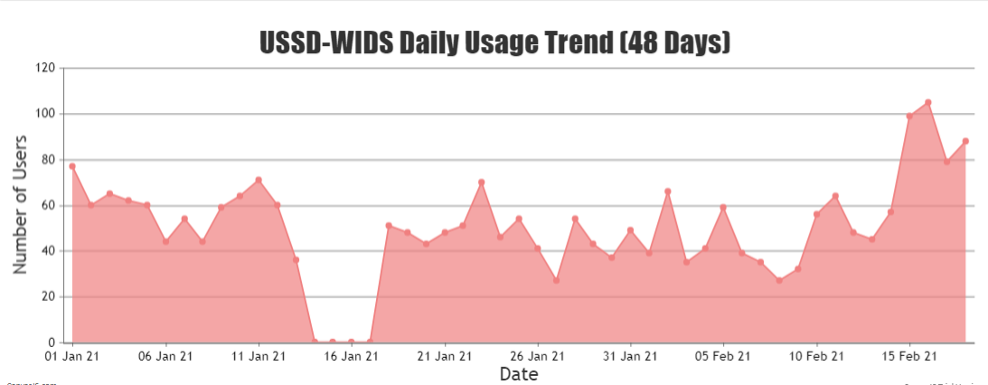

*Figure 12: 2021 daily USSD-Usage trend*

**Overall System Statistics**

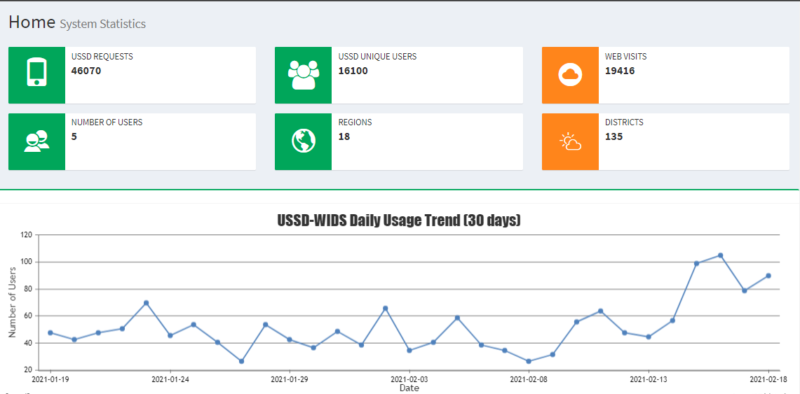

*Figure 13: Overall system statistics*

### 2.2.2. Number of successful Requests

A high number of complete requests indicates better performance of the system. Tthis is represented by the red line graph.

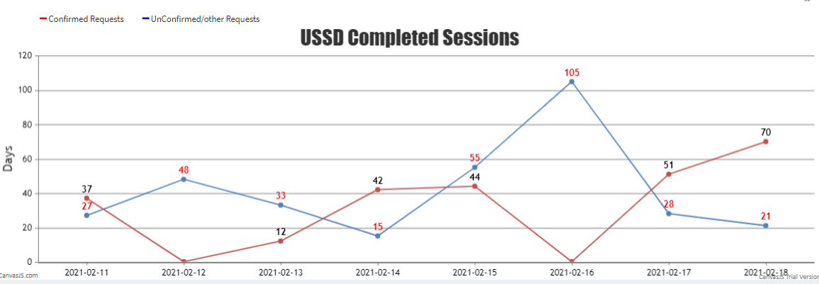

*Figure 14: Successful requests Vs other requests*

### 2.2.3. Feedback from users

The system automatically captures feedback from both web and USSD users.

Continuous feedback from the users informs improvements in the system i.e. by addressing the system complaints from the users and adding to WIDS suggestions from the users.

**2.2.4. Number of return users**

By comparing the requests of a given day with those of the previous day, you can easily estimate and see whether there is an increment in the number of return users, if there is an increment, this indicates that the number of return users has increased. Otherwise, if there is a decrease, this indicates that the number of return users reduced, therefore, the number of return users on a given day is an indicator on the demand of the forecasts disseminated by the system.

### 2.2.5. Downtime

Most users prefer using a system which is always up and running. Since the information that is disseminated by WIDS is in real-time (expire in a given period of time), it is important to make sure that the system’s downtime is very low, in order to improve on the timeliness and acceptability of the disseminated forecasts

## 2.3. Requirements for maintaining operation of WIDS

*Table 2: Requirements for maintaining operation of WIDS*

|  |  |
| --- | --- |
| **Requirement** | **Description** |
| USSD service providers | Provides a USSD Gateway that allows mobile subscribers to send USSD messages and to receive information and services from mobile operators, as well as third-party Value-Added Services (VAS). USSD messages are session-based, which means real-time connection is established for two-way data exchange. |
| Server | For the system to be used across the country, it is installed onto a networked server system that is accessible over the network.  The WIDS system is installed onto a server system that needs to be up and running at all times.  The USSD app depends on the WIDS system which relies on the server. |
| SMS service provider | Provides bulk messaging service which the system depends on to send forecast messages to USSD users.  The bulk SMS provider is controlled and regulated by the telecoms such as MTN and Airtel |
| Voice service providers | Provides voice service which the system uses to disseminate voice forecast messages to USSD users.  These voice service providers are controlled and regulated by the telecoms. |
| Forecast information | The WIDS system mainly depends on the forecast provided by UNMA. So, it is a mandate that these forecasts are provided to sustain the operation of the system. These forecasts are categorized into different products which include, daily, seasonal, marine and monthly forecasts. |
| Telecoms | Provide the technology necessary for communication through the internet, phone or wirelessly. Telecoms also provide an infrastructure necessary for passing voice, words, and audio weather information to various stakeholders. |
| Forecast translations | The WIDS system is a multilingual system, in that is disseminates forecast in different local languages, there it is required that the translations for the seasonal forecast are provided and uploaded into the system to cater for users that have difficulty understanding forecasts in English |
| Data Entrants | This is the personnel responsible for uploading available forecasts into the system. This makes information readily available for access by the end users. |

## 2.4. Challenges encountered in operationalizing WIDS

### 2.4.1. Cost of ICT Infrastructure and Services

Several ICT service providers have been engaged in ensuring that WIDS is operational. This comes at a fee, depending on the service provider. Table 3 provides the estimated operational costs that WIMEA-ICT and other stakeholders incur in order to keep WIDS operational.

*Table 3:Operational Costs of WIDS*

|  |  |  |  |  |
| --- | --- | --- | --- | --- |
| **No.** | **Service Provider** | **Cost** | **Source** | **Notes** |
| 1. | Hosting Services |  | WIMEA-ICT | This is paid per year |
| 2. | Bulk text messages | 35 units per message | WIMEA-ICT | This is paid per year |
| 3. | Audio Messages | Between UGX 1000 to 1500 | WIMEA-ICT | Only when the request is for audio messages |
| 4. | Cellular /Telecom | Between UGX 160 to 500 | Mobile subscriber | This fee is deducted from subscriber once they send a request via the USSD Code |
| 5. | USSD Code service | USD 250 Per month |  |  |
| 6 | Translation | UGX 7,000,000 per language per season | World Vision | A total of 9 translations have been made in both text and voice recordings |

The above costs have limited the adoption of WIDS in several ways. For instance, the charges incurred on the mobile subscribers have limited the frequency of requesting for the weather products. Some members have instead resorted to getting the seasonal forecast, which comes once in three or four months. Some extension workers in an effort to assist those who cannot afford have requested the forecast and later forward it to colleagues. This sometimes delays the delivery of the forecasts, and if the extension worker is unable to get the information, many do not receive the information.

Translation of the forecasts has been a subject of availability of funds in the Organization. In case receipt of funds is delayed, translation is also delayed. Furthermore, despite the many languages in Uganda, only 9 languages have been translated. Moreover, only seasonal forecasts are the only ones translated.

### 2.4.2. Challenges in Raising Awareness

WIDS was developed in 2016. However, partial adoption and use of the system was only realized in 2019, where requests went from less than 10 to 1000 requests in a day. Despite the increase in the number of requests, thousands of people still do not receive the weather information. This is mainly because many people are still not aware of the system. The project embarked on raising awareness in 2019 with a goal of promoting the seasonal forecast among farmers. *Table 4* shows the platforms used to raise awareness of the system

*Table 4: Platform/ methods used to raise WIDS awareness*

|  |  |  |
| --- | --- | --- |
| **No.** | **Platform** | **Cost** |
| 1. | Radio |  |
| 2. | Television |  |
| 3 | Social Media |  |
| 4 | Official WIDS Launch |  |
| 5. | Field visits for promotional workshops |  |
| 6 | Publications |  |
| 7 | Print Media |  |
| 8 | Quarterly Newsletters |  |

The means of raising awareness of the system, although have advantages, are also disadvantageous. For instance, the cost of disseminating via the media is prohibitive. Moreover, most of the radio and TV stations reach a small area. These TV and radio stations further require the messages to be translated, hence, additional costs.

The quarterly newsletters circulated in academic networks and often failed to reach the main intended user, who is the farmer

Since the project needed to reach many places, many people were required to visit the places. Teams that were formed consisted of 12 people who required facilitation in form of accommodation and meals. These costs limited the number of people and places reached by the teams. Moreover, on some occasions, mobilization of people for the training and awareness workshops required a coordinator who doubled as a translator especially in areas outside the Buganda region. These coordinators attracted an additional cost.

### 2.4.3. Skill level of developers

The WIDS system was mainly developed by project interns of different intakes. This was challenging in a way that every year WIMEA had to recruit new interns. Sometimes these interns would graduate and seek jobs in other companies, bringing the development of the system to stand still. The newly recruited interns needed fresh hands-on training and guidance on the customization of the system. As a result, a lot of time and other resources were wasted in training the newly recruited team to continue with the process of development.

So as WIMEA, this was a challenge on the side of the development of the system.

### 2.4.4. Interruptions in Technology

WIDS had multiple interruptions during the life of the project. These have been categorized based on the service providers as indicated in Table 5 below.

*Table 5: Service Provider Technology failure*

|  |  |  |  |
| --- | --- | --- | --- |
| **No.** | **Service Provider** | **Disruption** | **Impact** |
| 1 | Hosting service provider | Power failures, security restrictions, which limited access | Limited or no accessibility to the system |
| 2 | USSD Code service providers | Failure in accessing the USSD Code, Failure to pay MTN license, hence the inability of MTN subscribers to access the forecast | Reduced number of forecast requests  Damages the already secured reputation |
| 3. | Bulk SMS and Voice service | Failure of servers | Failure to deliver forecast messages  System breakdowns |
| 4. | Cellular service | Service timeout | Delayed or failure to deliver messages |

### 

### 

### 2.4.5. Accuracy and timeliness of forecasts

It is not only the improved quality of available weather forecasts that defines the value of weather information. The way in which the weather and climate information is communicated and how it is being utilized by decision-makers are highly relevant steps in a weather service value chain, though sometimes this has been a challenge. The forecasts (daily forecasts) tend to be a bit inaccurate and sometimes not disseminated in reliable time.

Inaccurate forecasts (especially daily forecasts) tend to develop bias in the users of the system since they generally consider the information being disseminated as always inaccurate.

The inaccuracy of the forecasts might be due to the fact that they are not area-specific; most of the forecasts that are provided by the meteorological agency are based on district level; they do not narrow down to counties and sub counties within a specified district.

### 2.4.6. The cost of missing a forecast

Since the system is mainly furnished by weather products from UNMA, in case these forecasts are not available then it is good to say that the system has nothing to disseminate. The following are impacts of missing a forecast:

1. **Failure to deliver forecast information to the subscribed users**

The system has a module for user subscriptions. The subscribed users are supposed to receive forecast updates of the product they subscribed to. Therefore, in case of a missing forecast, these users don't receive the weather (for the case of daily forecast) and climate (for the case of seasonal forecast) information via a push method.

1. **Reduced number of daily requests**

In case of missing forecast, the number of daily system users greatly decreases due to the fact that the system has no weather and climate information to disseminate.

1. **Lack of trust from the already secured users**

Missing a forecast for more than two days could result in lack of trust from the subscribed users or farmers. This was evidenced by a sharp decrease in the number of return users when the forecasts were missed for over a period of three days.

1. **Poor timeliness and accessibility of forecasts**

The delays which were associated with forecast delivery in some days entirely affected their dissemination via the WIDS system. This as a result affected the trust, we had from some of the frequent users of the system, this was observed in the user feedback received from both the WIDS USSD and the website.

Users arouse a number of complaints as a result of delayed forecast delivery by UNMA on certain occasions.

For certain instances, forecasts were not received or provided by UNMA, this affected accessibility to the USSD since it depends on current forecasts of a day.

1. **Disseminating invalid information**

Dissemination of information that is no longer useful to intended users; especially early warnings that can end up being useless to intended sectorial users.

1. **Loss of Subscribers**

Frequent users that usually check up on the system for forecast tend to rely on it as time goes on, but continuous missing of forecasts affects the validity of the system and its reliability.

### 2.4.7. Limited Number of Weather and Climate Products

As earlier said, the system depends on the weather products provided by UNMA of which these are limited. Currently, the system can disseminate only four products, namely: Daily, Seasonal, Marine, and Monthly forecasts. However, during the workshops and group discussions held by WIMEA-ICT with farmers from different regions of the country, most of the farmers preferred receiving hourly forecasts, weekly and dekadal forecasts (10-day forecasts), but unfortunately these are not available. The few that are available (like dekadal forecast) are not disseminated in a structure that can easily be understood by the native farmers.

### 2.4.8. Translating forecasts

The forecasts provided by UNMA are in English but there is a need to provide translations to other languages. This comes as a result of complaints aroused by farmers (native users) having some issues understanding the English language thus the need for the translated version of the forecasts. Unfortunately, not all of the forecasts are translated; Only seasonal is translated.

Translations for the seasonal forecast are given in a number of languages namely Acholi, Luganda, Runyankore, Lugbara, Japhadohla, Rutoro, Lusoga, Karamojong, Lusamia were later provided by World Vision. These language translations were not enough because there are a large number of languages being spoken in Uganda and not all individuals understand at least any of the language translations currently being provided. The limited number of translations for the seasonal forecast has limited the extended utilization of the system by users in all parts of the country, especially those upcountry, due to language barrier and yet they would find the information helpful since most of them practice farming.

WIMEA-ICT has always been incurring a hefty cost in securing the translations to the forecasts whenever a new seasonal forecast was released by UNMA. The cost per translation is about UGX 7,000,000, and this is paid for all the languages received every season. Annually, three - four seasonal forecasts are released. So, on average a total cost of about UGX. 28M could be spent on translating forecasts.

Sometimes the few translated seasonal forecasts provided by World Vision are not delivered in time and this hinders the timeliness of the disseminated forecasts.

### 2.4.9. Information entry

Most of these forecasts are fed into the system using entry forms. This required additional manpower to make sure the forecasts were uploaded in time. But this was quite tiresome and tedious due to the fact that the data uploaded was much, for instance the daily forecast had about 53 entries and the information had to be summarised to its simplicity so that it can be easily understood by the end users.

For some forecasts such as the Marine, data entry is so tedious and tiresome since the form is so big as it requires a lot of information to be entered before it can be saved.

Consider the sample forecast form for the Marine forecast as shown in Figure 15.

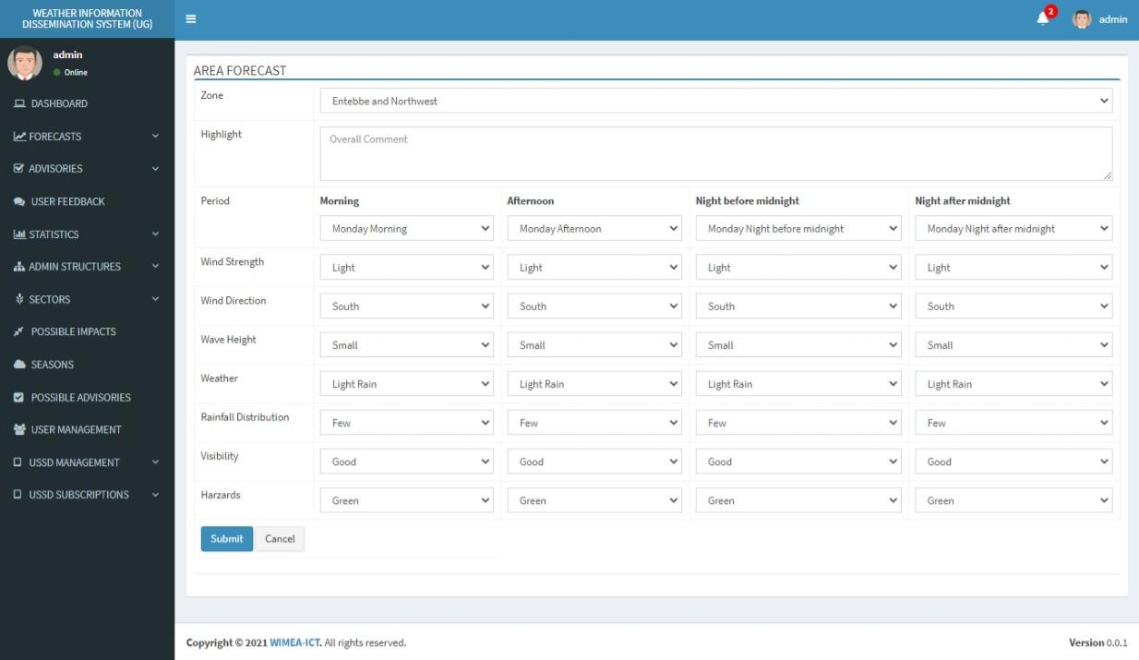

*Figure 15: Sample forecast form for the Marine forecast*

To move away from using forms which were tedious and tiresome, the WIMEA Team developed a software module that was integrated into the system, in order to automatically upload the daily forecast in the shortest time possible with less effort.

The uploader was developed based on sample PDF document structures for mainly the daily forecast because it’s this forecast that has many regional information and needs to be uploaded on a daily basis or on an interval of 6 hours. The uploader is to simplify forecast uploads in a matter of seconds.

Unfortunately, at times these PDF documents changed and the data entrant would resort to using forms.

**2.5. Popularising WIDS**

Agriculture in Uganda is rain-fed therefore weather and climate are the main drivers of production. Variability in weather often influences farmers’ decisions such as choice of agricultural enterprise to engage in, crops to grow, when to plant. It may also deter farmers from adopting new technologies and market opportunities. While taking such risks could improve yields and boost profits in a good season, extreme weather events such as drought or outbreak of disease can wipe out crops or livestock, leaving farmers impoverished. Institutions that influence and support farmers, such as national agricultural research and extension systems and development NGOs, are also affected by weather and climate uncertainty because it affects the type of backup that they provide to farmers. Climate uncertainty also has a negative impact on the providers of credit and markets for productive inputs and can make it difficult for smallholder farmers to benefit from agricultural markets. Weather and climate information can reduce uncertainty and support farmers in making decisions to reduce risks associated with their agricultural enterprises. Responding to climate variability and change in agricultural communities will be incomplete without access to weather forecasting and early warning information. The forecasts can provide advanced information so that farmers can adjust critical agricultural decisions, thereby improving efficiency, and enabling them to adopt the most suitable coping strategies.

WIDS closes the gaps that were being faced in the dissemination of weather information to different stakeholders across the Country. Several Campaigns have been undertaken in making the public aware of this tool and in all those campaigns the public is embracing WIDS and using it.

**2.5.1 Farmer group discussions**

In 2019 a team of 5 marketing students together with some technical systems developers of the Weather Information Dissemination System embarked on the task of marketing the system with an objective of popularising and disseminating it to the local farmers and to all the various agricultural stakeholders. The team used various dissemination modes with each having its own objective and expected subscription attached to it.

**2.5.2 Regional launches and radio talk shows**

The genesis of this move began with visits to small farmer groups coupled with radio talk shows, advertisements, exhibitions, workshops, Field outreach, Expos Social Media and the regional countrywide trip that we carried out to climax the project.

The marketing teams’ campaign was so pivotal in propelling the subscriptions to their current status and was mainly hinged on reaching out to the local farmers in their respective villages via all the above-mentioned modes of dissemination

The spot adverts that were run on Radio stations were in the native languages. These included:

* Luganda on BukeddeFM,Lusoga on Baba FM,
* Samia on Joggoo FM ,
* Runyakole and Rutooro on Radio West and
* Japhadhola on Rock Mambo FM.

All radio station adverts were drafted as “ *Dear listeners ,Plan your day and farming activities better with timely weather forecast information Just dial *255*85# or Visit “wids.mak.ac.ug/WiDS*” This message is brought to you by NORAD,WIMEA-ICT at Makerere University and Uganda National Meteorological authority.

The team also procured publicity material such as handbills,fliers and brochures plus banners that were always used to increase visibility and sensitization about the USSD when in the field.

**Composition of marketing materials**

* Fliers
* Pull up banners
* Handbills
* Radio spot adverts
* Radio talk shows
* Social media digital graphics on Facebook, Twitter and online blogs
* Social Media messages on Facebook, Twitter and Online blogs.

*Table 6:Summarized table of all marketing strategies*

|  |  |  |  |
| --- | --- | --- | --- |
| **ACTIVITY** | **MODE OF DISSEMINATION** | **NUMBER OF MARKETEERS** | **NUMBER OF SUBSCRIPTIONS ATTAINED** |
| Mpelerwe(MukyalaGitta ) 15th /11/2019 | Field outreach | 5 | 10 |
| Harvest Money expo  (Organised by Vision group at Namboole stadium) | Field outreach | 5 | 232 |
| Esella Hotel (popularisation of Meteorology in schools) | Workshop | 4 | 44 |
| Kamuli farmers group | Field outreach | 3 | 38 |
| College of agricultural and environmental sciences exhibition at Makerere University | Exhibition | 5 | 98 |
| MpelerweMukyalaGitta(9th July 2020) | Field outreach | 2 | 55 |
| Weather adverts about WIDS on all the most influential regional stations (20th JUNE- 20th JULY 2020) | Radio adverts | 5 radio stations |  |
| Regional WiDS trip (11th September 2020-18th September 2020) | Workshop with farmers and Radio talk shows in each Region | 4 WIMEA people and 2 officials from UNMA | 7051 |
| Social Media | Facebook, online blogs and WhatsApp |  |  |

The marketing team was able to gather over 46020 total requests and 16071 unique subscriptions as of today and seemingly the Radio talk shows that were done together with workshops about sensitizing the District production officers (DPOs) and Chief administrative officers (CAO's) gunnered more subscriptions than the rest of the marketing strategies

**2.5.3 Ranking of strategies**

**Best Strategy**

The Radio talk shows, adverts and regional dissemination trips were the best alternative as these were able to give us a weekly figure of over 3,000 subscription despite the technical challenges we had. The same approach continued to give us more daily subscriptions since the inception of the idea to date.

**Worst strategy**

The worst alternative was that of the field outreach as it gave less subscriptions with high expenses that can’t be traced down to performance or post field outreach subscriptions. These outreaches also attracted less attendants due to the time factor of conducting them during the day, when most farmers are in their gardens as opposed to Radio talks shows that were conducted at night in farmers programs.

**2.5.4 Field challenges**

* Delay of Feedback from the system
* Systems break down in the code with displays such as “error occurred” and “external application down”.
* Airtel messages used to take long to come back to the subscribers
* Non uniform SMS tariff charges on the same network
* Farmers complained about the system not being translated in other local languages
* The system had a breakdown during the Covid pandemic and this gave farmers a hard time to access it

**2.5.4 Feedback / recommendations from field**

* Localize the weather information to farmers regionally
* More dissemination material such as fliers and online blogs are still needed
* Use radio stations and farmers associations more to publicise
* Negotiate with Airtel and MTN to cut on the costs of subscriptions
* Translate the website into local languages as well
* We should target village people more because they are the ones that need the weather information
* The system should have climatic messages on wetlands and water body conservation

**2.5.5 Recommendations to UNMA**:

There is need to always make mention of WIDS on all weather and climate talking platforms in which UNMA is involved

There is need to have WIDS running on their Website

# Sustainability Plans

## Source code

WIDS is an Open-source software (OSS) (type of computer software in which source code is released under a license in which the copyright holder grants users the rights to use, study, change, and distribute the software to anyone and for any purpose).The source code for all the products is open -source.

Source code is provided on the github repositories by WIMEA. The installation and customization documentation is also made available to help and guide users as they install and customize the system to suit their needs. A system usage manual is also provided to help users navigate around the system as they interact with it.

The website source code can be accessed from

<https://github.com/wimea-ict/WIDS-UGANDA.git>

The USSD source code can be accessed from

<https://github.com/wimea-ict/USSD-APP.git>

## 3.2 Support documentation

All the documentation including system manuals and technical guides are to be handed over to the UNMA team. The provision of these documents will ease the customization and usage of the system. Therefore, in case new requirements come in when the system is already handed over to UNMA, the technical team at UNMA will be able to integrate these changes since the system technical guides and user manuals will be available. But also on another note, the technical team at WIMEA will always provide support and help if needed.

The following support documents are to be provided:

*Table 7: Support documents*

|  |  |
| --- | --- |
| **Document** | **Description and Purpose** |
| WIDS web user manual | Contains all essential information for the user to make full use of the WIDS system. This manual includes a description of the system functions and capabilities, contingencies and alternate modes of operation, and step-by-step procedures for system access and use. |
| WIDS Web technical guide | Contains instructions for operation, installation, use, maintenance, support and any requirements for training for effectively using the WIDS Web application. |
| WIDS USSD technical guide | Contains instructions for operation, installation, use, and maintenance of the WIDS USSD application. |

## 3.3. Incorporating New Requirements

Every system requires updates and upgrades so as to continuously meet the key requirements of users (which are ever changing overtime). For instance, before (in 2019), the WIDS USSD App was not capable of disseminating marine forecasts, but due to the demand of this product from various users especially fishermen around lake Victoria, the team had to update and integrate this module into the system.

Therefore, anytime new requirements can rise up and then require customization and re-design of the system. But in case the new requirements come in, the WIMEA-ICT team is ready to take action and give support if needed or contacted.

## 3.4. Operation Costs

For continuous operation of the WIDS system, some unavoidable costs have to continuously be made to keep the system running.

Several ICT service providers have been engaged in ensuring that WIDS is operational. This comes at a fee, depending on the service provider.

*Table 8: Operational Costs of WIDS*

|  |  |  |  |
| --- | --- | --- | --- |
| **No.** | **Service Provider** | **Cost** | **Notes** |
| 1. | Hosting Services |  | This is paid per year |
| 2. | Bulk text messages | Unit cost of an SMS is UGX.30 | The SMSes are purchased in bulk to cater for the increasing number of USSD requests. |
| 3. | Audio Messages | Ranges between UGX 500 to 1200 per voice call message | Only when the request is for audio messages |
| 4. | Cellular /Telecom | Between UGX 160 to 500 | This fee is deducted from subscriber once they send a request via the USSD Code |
| 5. | USSD Code service | USD 250 Per month |  |
| 6 | Translation | UGX 7,000,000 per language per season | A total of 9 translations have been made in both text and voice recordings |

## 3.5. System Hosting

Planned transfer of the database and other server resources is underway such that the system is hosted on UNMA servers. The database shall be exported from Makerere University servers to UNMA servers. This is intended to maintain the old data and statistics for the previous years.

## 3.6. Translations

As previously said, WIDS is a multilingual system, and therefore there is a need to have translations for forecasts especially seasonal; so as to increase system outreach and accessibility by various stakeholders; especially the local farmers who can not understand English.

During the regional launches and radio talk shows many people were willing to do this activity at a free cost. Therefore there is a need to engage them and be brought on board.

## 3.7. Awareness

There is a need to raise more awareness about the WIDS system. Currently, the system has about 46344 USSD requests and 16201 unique users, but this is a very small number when compared to the total number of about three million farmers in the country**. *Refer to section 2.5.3*** for the best strategy to undertake so as to raise more awareness.

## 3.8. Collaboration

The operation of the WIDS system depends on a number of stakeholders (who provide different services and products) as earlier stated in the previous sections. Therefore, there is a need to maintain a close collaboration and communication with these stakeholders especially bulk SMS providers, USSD service providers, Farmers and ICT enablers.

**3.9. Weather and Climate Information Entry**

The weather information the system disseminates is always uploaded on a daily basis for the case of daily or on a 6-hourly interval. Therefore, there is a need to acquire a data entrant(s) who will always be available to upload the information into the system.

For the case of daily forecast, this information can be uploaded by form or using a PDF automatic uploader.

Also, the seasonal forecast provided by UNMA is too technical to be understood by the end users, so the data entrant is meant to summarize the information before upload to make it simpler and understandable.

**3.10. Skilling Staff on Maintenance of WIDS**

In addition to source code and documentation, the WIMEA-ICT team is ready to conduct training sessions with the UNMA team on the accessibility and customization of the WIDS system so as to make the transition and maintenance as easy as possible.

**3. 10.1 Aims of conducting training sessions**

The following are aims of skilling staff on Maintenance of WIDS:

* Provide a smooth and efficient transition of system maintenance from WIMEA-ICT to UNMA.
* Promote easy customization of the system in case of new requirements and changes.
* Facilitate continuous operation of the system (both USSD mobile application and the web portal).
* Enable UNMA staff understand both operation and technical usage of the system
* Allow UNMA staff to understand how forecasts are uploaded into the system.
* Promote an understanding of the different dependencies of the system, that is, bulk messaging API, USSD extension services, voice messaging API and other technical functionalities.

# Proposed Handover Plan

The handover process was planned based on the following

*Table 9: Handover process plan*

|  |  |  |
| --- | --- | --- |
| **No.** | **Activity** | **Preferred Period** |
| 1. | Software, comprising of the web system and USSD system |  |
| 2. | System access and control |  |
| 3 | Operational Costs |  |
| 4 | System Manuals and related documentation |  |
| 5 | Hardware |  |
| 6. | System development |  |

# Recommendations

Farmers revealed that the audio message weather forecasts are the most useful to them

There is need to improve the message time lag

There is need to add more translations of the weather forecasts

Add in a Market platform for farmers to market on the website

Simplify the weather forecasts to give summarised and relevant information especially to farmers

Implement offline resources for weather while the costs are met at a strategic level

Engage OPM about the app and integrate the system with district disaster management committees

More weather stations needed

Create synergies to help disseminate information with bodies like FAO,WFP , NARO and NAADS

During dissemination Leaders (i.e Local, Political, Religious and Socio-Economic) should be involved

Inclusion of an agricultural price /marketing platform for herbicides/vermicides /crops and fertilizers.

The system should have climatic change messages/alerts on wetland and water body conservation

The system should have climatic change messages/alerts on wetland and water body conservation

Farmers can greatly reduce the Text SMS Costs and Audio Message Costs by making requests in their farmer groups rather than individually.

**References**

1. Africa Climate Change Resilience Alliance and UNMA (2014). The Climate Forecast Model. Africa Climate Change resilience Alliance.
2. OECD (2009). Managing Risk in Agriculture: A Holistic Approach. OECD.